**CN LAB 2 REPORT**

**BUS TOPOLOGY:-**

Bus topology is a network configuration where all devices are connected to a single central cable, called the bus. Data sent by any device travels along this bus and can be received by all other devices, with terminators at each end to prevent signal reflection. It is simple, cost-effective, and easy to extend, making it suitable for small networks or temporary setups. However, it has limitations in cable length, can experience data collisions, and is harder to troubleshoot, making it less ideal for larger, high-traffic networks.

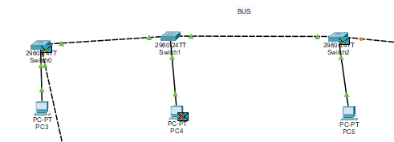

Ping :-

Pinging the other PC in the same BUS topology.

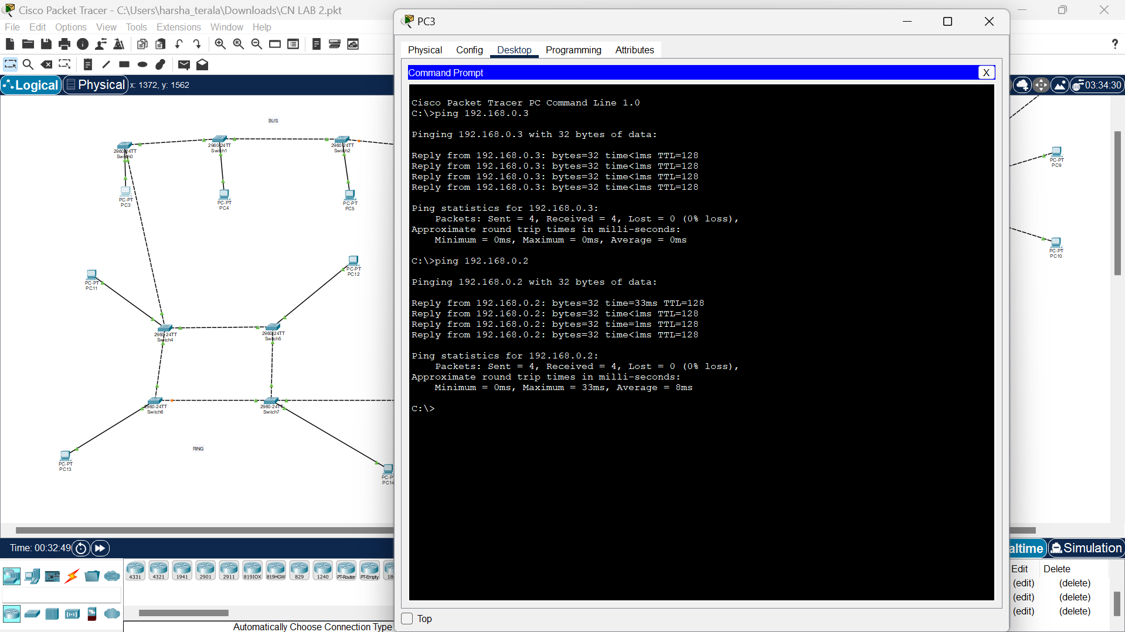

Above figure represents the successful message of ping.

**STAR TOPOLOGY:-**

Star topology is a network configuration where all devices are connected to a central hub or switch. Each device has a dedicated cable that connects it to this central point. This setup ensures that data sent from any device is directed to the central hub, which then forwards it to the intended recipient. Star topology is easy to install and manage, offers good performance due to reduced data collisions, and simplifies troubleshooting since issues can be isolated to individual connections. However, its main disadvantage is that if the central hub fails, the entire network goes down. This topology is commonly used in home and office networks for its reliability and ease of maintenance.

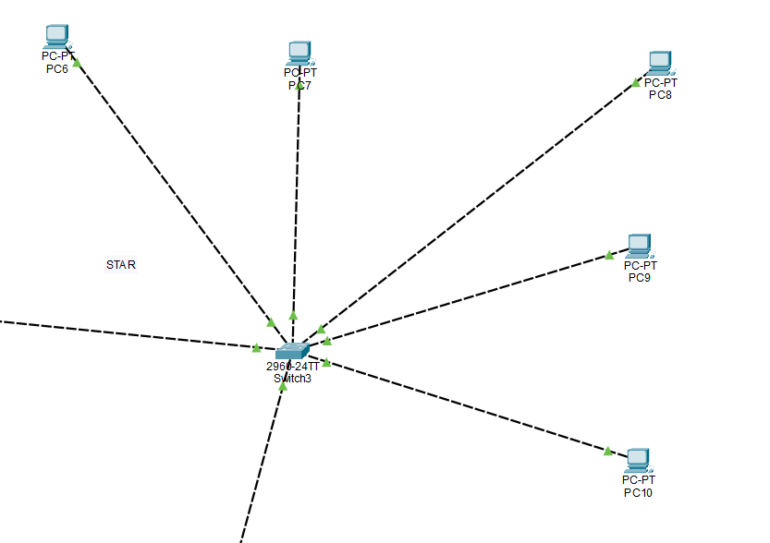

Ping :-

Pinging the other PC in the same STAR topology.

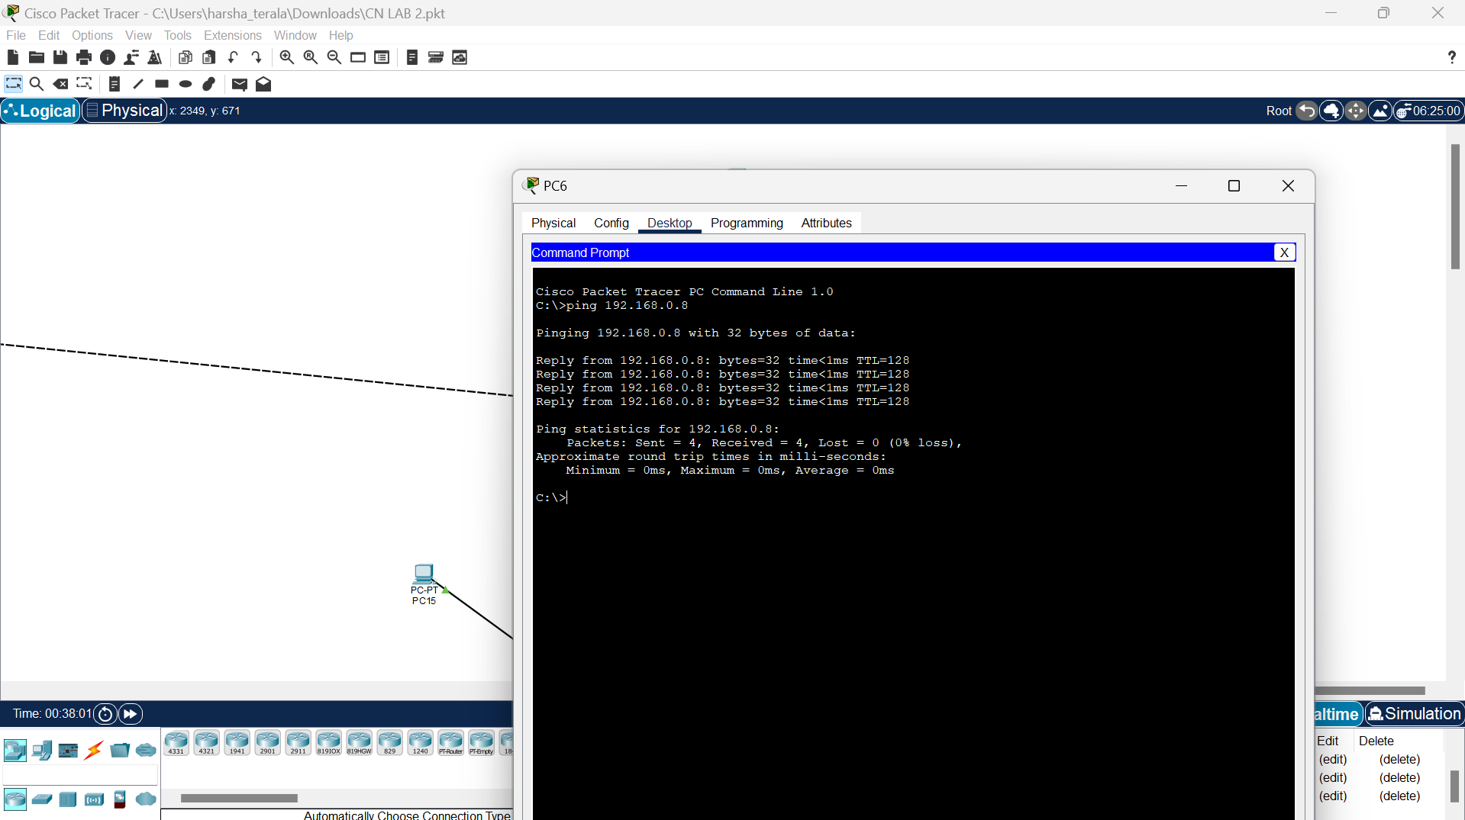

Above figure represents the successful message of ping.

**RING TOPOLOGY:-**

Ring topology is a network configuration where each device is connected to two other devices, forming a circular loop. Data travels in one direction (or both directions in a dual ring network), passing through each device until it reaches its destination. This setup reduces data collisions and can handle high traffic efficiently. However, if one device or connection fails, it can disrupt the entire network, and adding or removing devices requires temporary network downtime. Ring topology is commonly used in local area networks (LANs) and some wide area networks (WANs) where high-speed, predictable data flow is essential.

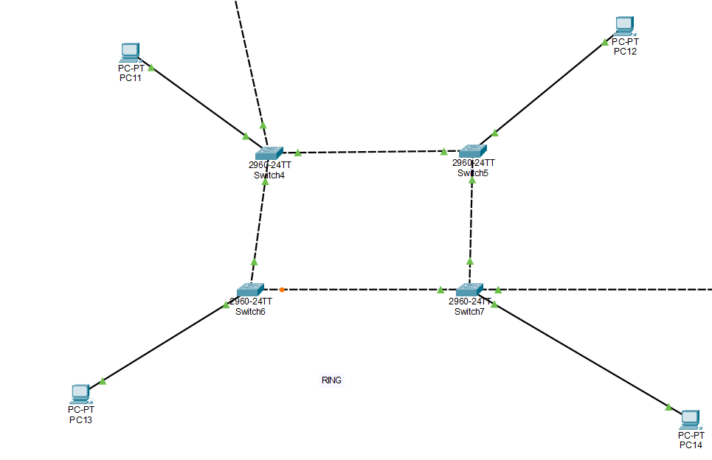

Ping :-

Pinging the other PC in the same RING topology.

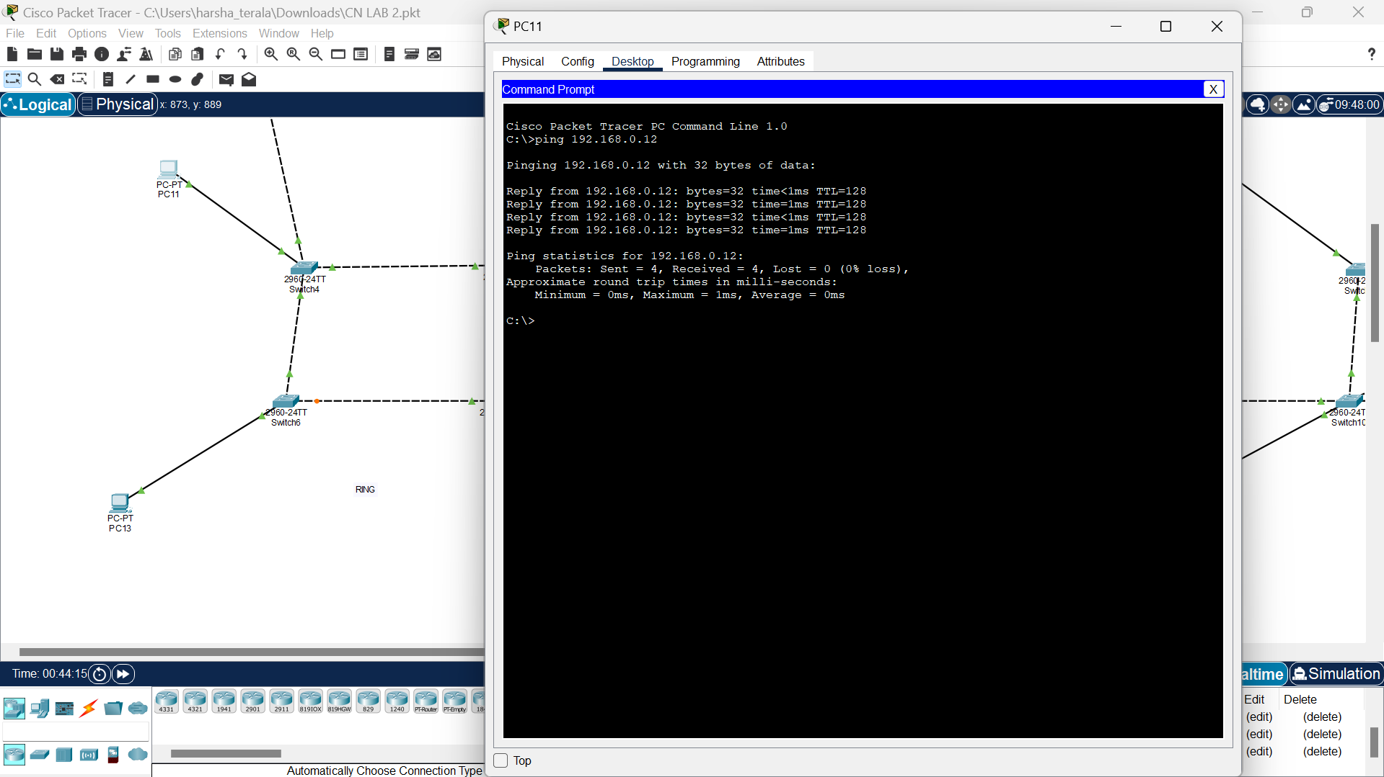

Above figure represents the successful message of ping.

**MESH TOPOLOGY:-**

Mesh topology is a network configuration where each device is connected to multiple other devices, allowing for multiple data pathways and ensuring high redundancy and reliability. If one connection fails, data can be rerouted through other connections, making the network highly fault-tolerant. There are two types: full mesh, where every device is connected to every other device, and partial mesh, where some devices are connected to all others while others are connected to just a few. This topology is complex and costly due to the extensive cabling and configuration required, but it is ideal for critical applications like military communications and data centers where high availability and reliability are essential.

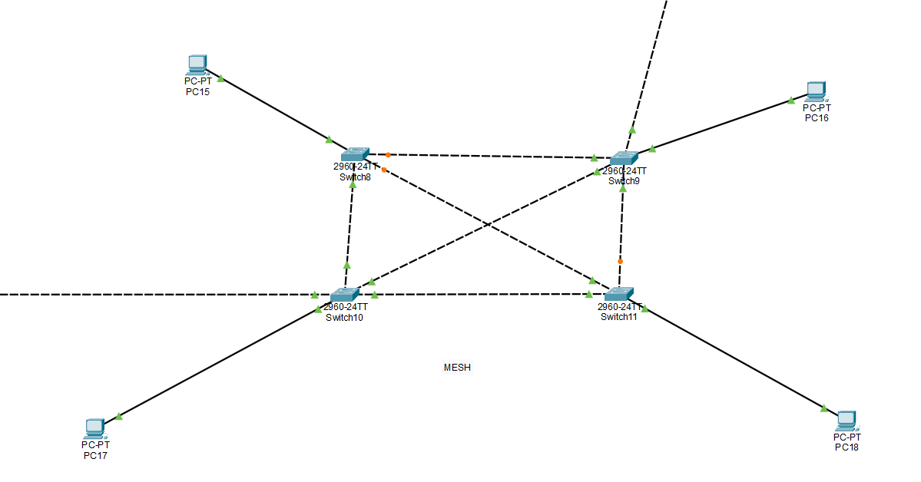

Ping :-

Pinging the other PC in the same MESH topology.

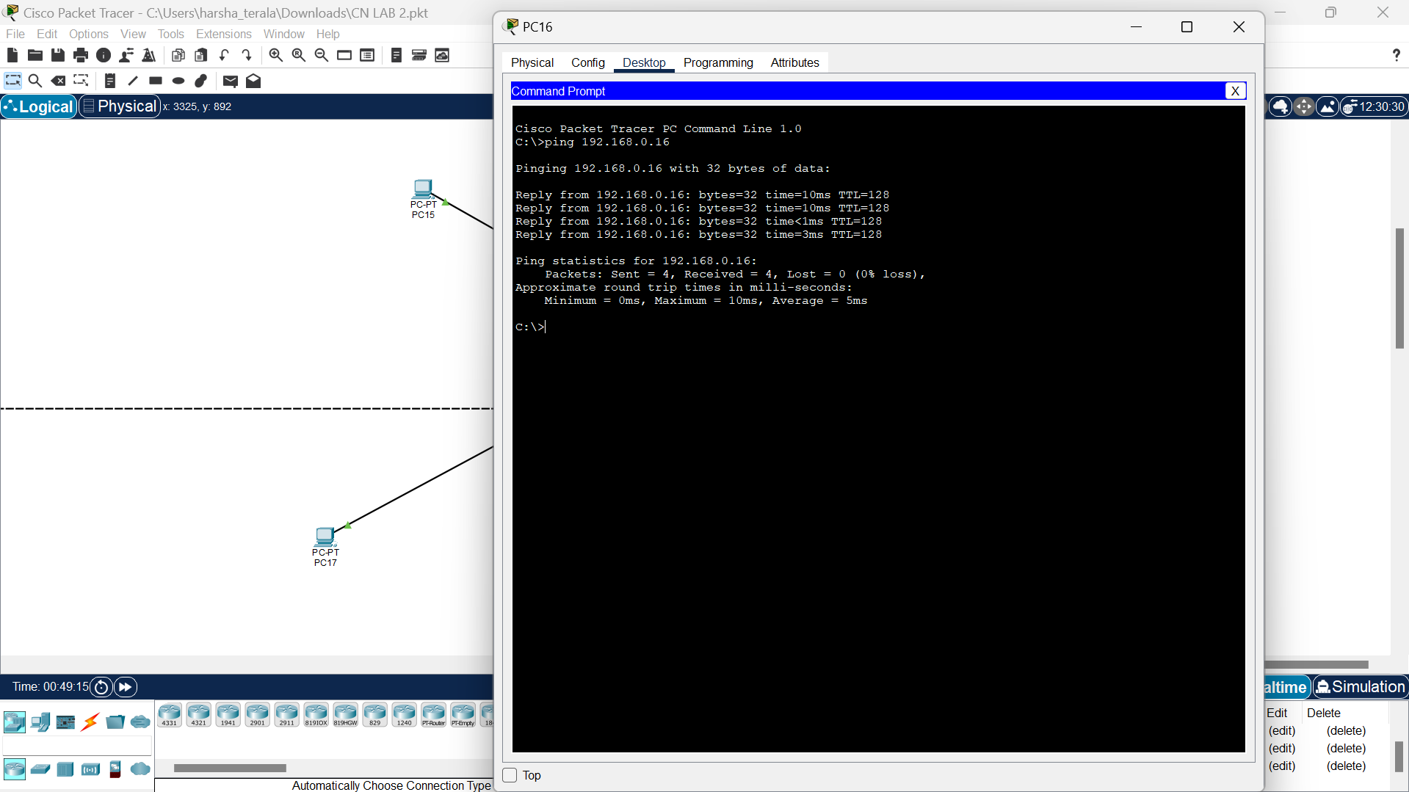

Above figure represents the successful message of ping.

**Summary of Network Topologies:-**

**1. Bus Topology:**

- Structure: All devices are connected to a single central cable (bus).

- Advantages: Simple, cost-effective, easy to extend.

- Disadvantages: Limited cable length, collision-prone, difficult troubleshooting.

- Use Cases: Small networks, temporary setups.

**2. Star Topology:**

- Structure: All devices are connected to a central hub or switch.

- Advantages: Easy installation and management, good performance, easy troubleshooting.

- Disadvantages: Central hub failure can bring down the entire network.

- Use Cases: Home and office networks.

**3. Ring Topology:**

- Structure: Devices are connected in a circular loop.

- Advantages: Efficient data transmission, no data collisions.

- Disadvantages: Network disruption if one device fails, complex to add/remove devices.

- Use Cases: LANs, some WANs and MANs.

**4. Mesh Topology:**

- Structure: Each device is connected to multiple other devices.

- Advantages: High reliability, fault tolerance, scalability.

- Disadvantages: Complex setup, high cost.

- Use Cases: Critical applications like military communications, data centers.

**Implementing Topologies in Cisco Packet Tracer:-**

Cisco Packet Tracer is a network simulation tool that allows for the design and testing of network topologies. Here’s how to implement these topologies:

**1. Bus Topology:**

- Setup: Connect all devices to a single linear cable using appropriate network interfaces.

- Components: Use routers/switches and end devices with Ethernet cables.

- Simulation: Test data transfer between devices and ensure proper terminators at both ends.

**2. Star Topology:**

- Setup: Connect each device to a central switch/hub using straight-through Ethernet cables.

- Components: Central switch/hub, computers, printers, and other peripherals.

- Simulation: Check data flow through the central hub and ensure all devices can communicate with each other.

**3. Ring Topology:**

- Setup: Connect each device to two other devices in a circular layout.

- Components: Use routers/switches and configure them in a ring formation.

- Simulation: Ensure data packets travel correctly around the ring and handle any potential failure scenarios.

**4. Mesh Topology:**

- Setup: Connect each device to multiple other devices to form a mesh.

- Components: Multiple routers/switches interconnected with Ethernet cables.

- Simulation: Test the network’s fault tolerance by disconnecting various links and observing the rerouting of data.

**Steps for Cisco Packet Tracer:-**

**1. Design the Network:**

- Drag and drop devices (computers, switches, routers) onto the workspace.

- Use the “Connections” tool to link devices using appropriate cables (straight-through, crossover).

**2. Configure Devices:**

- Assign IP addresses to devices.

- Configure routing protocols if necessary (e.g., RIP, OSPF).

**3. Test Connectivity:**

- Use the “Add Simple PDU” tool to test connectivity by sending ping requests between devices.

- Monitor traffic using the simulation mode to ensure data packets are correctly routed.

By understanding and implementing these topologies in Cisco Packet Tracer, you can design and test various network configurations, ensuring they meet the required performance and reliability standards.